LAB 8
Joins

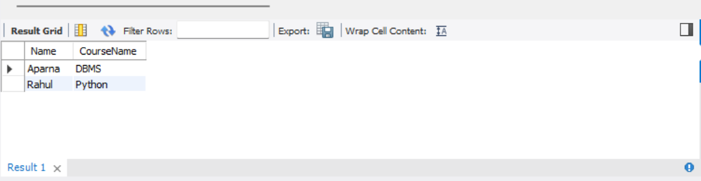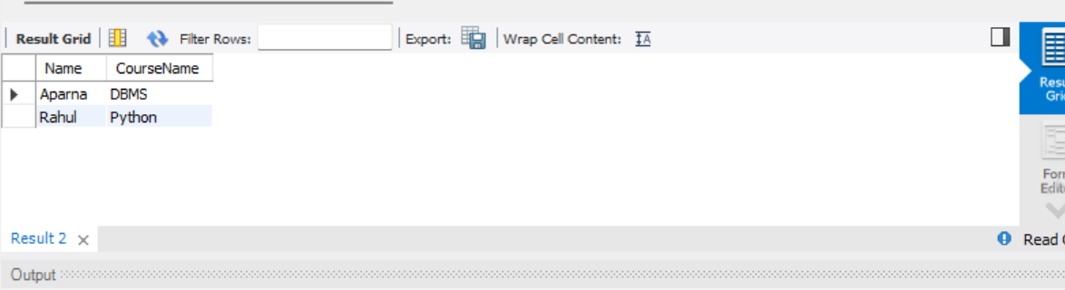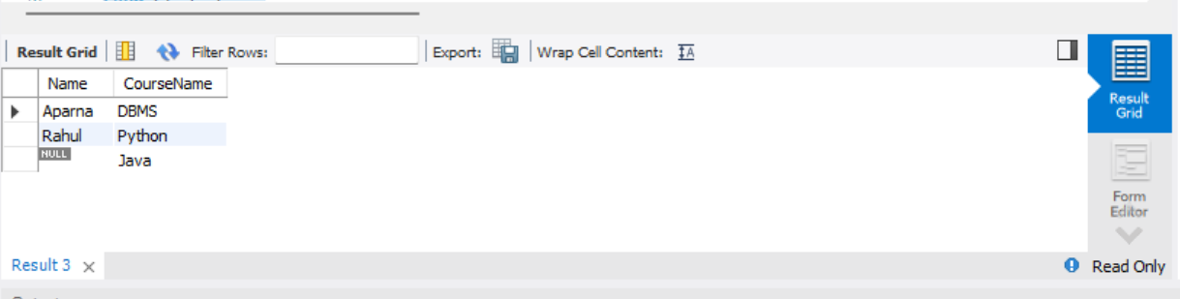
1. INNER JOIN: Displays the names of students and their course names when the StudentID matches in both tables.
2. LEFT JOIN: Displays all students and their matching course names. If a student has no matching course, NULL is displayed.
3. RIGHT JOIN: Displays all courses and their matching student names. If a course has no matching student, NULL is displayed.
4. FULL OUTER JOIN: Displays all students and all courses, including matching and non-matching records. Missing values are displayed as NULL. Note: MySQL does not directly support FULL OUTER JOIN.

